**Animation Project**

By Yashasvi Pamu

11715686

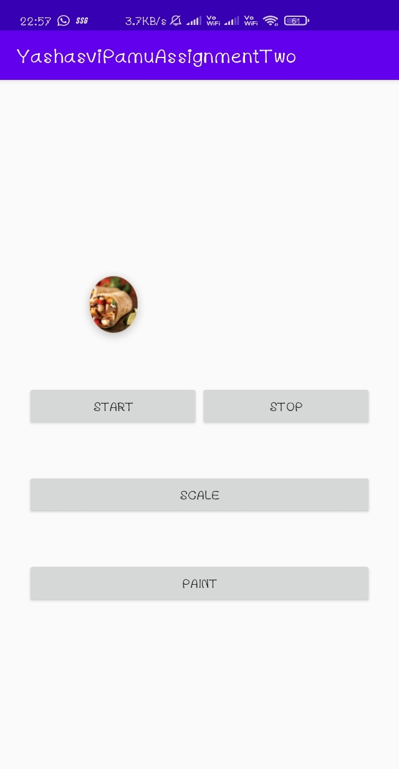

This is the home page of the project where we see a image of a food icon which moves up and down diagonally on the click of start button and stops the animation when stop button is pressed. Scale button increases the size of the food icon using zoom in and then decreases the size using zoom out. It also does a 360 degree turn while zooming in and out. And last but not the least the paint button which when pressed overrides the transition animation to a custom one which pushes the layout to right and the next activity which is a drawing board shows up.

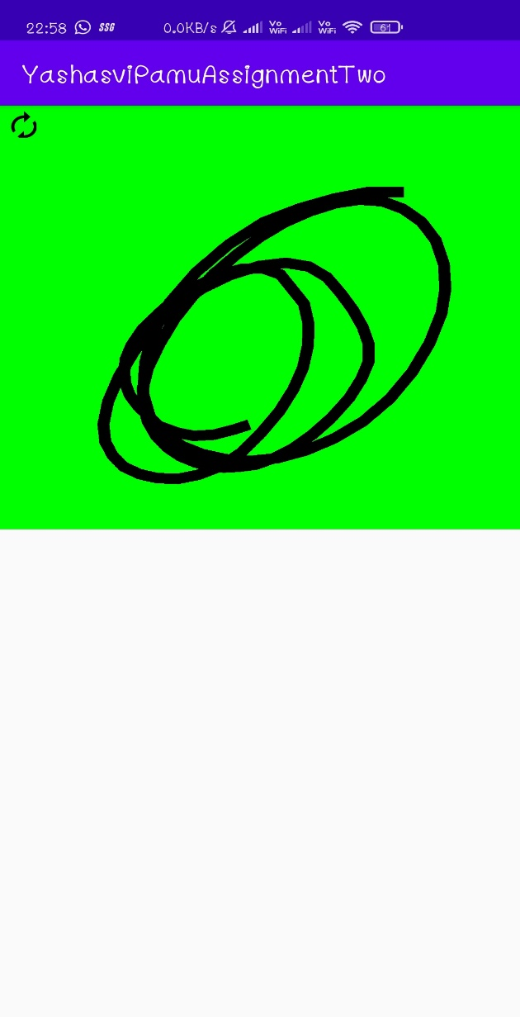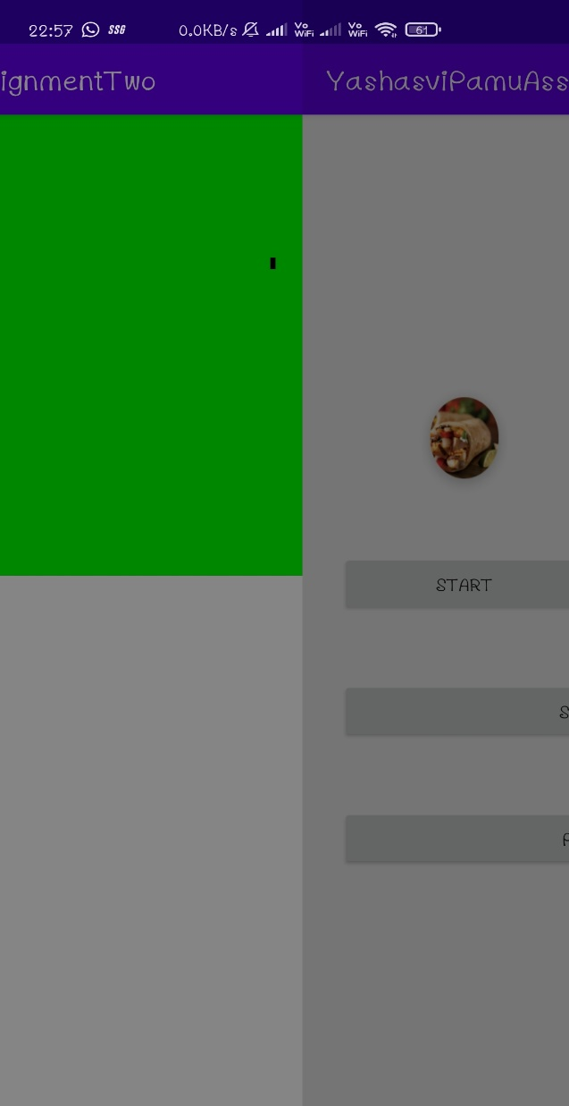

As you can see here the left image is the transition animation taking place and the right image is the canvas with the background green where the user can draw using touch. And as you can see a refresh icon on top when pressed clears the drawing and makes it clean.

And below is a working demo of the project:

